State of the Industry 2025
By NostraData General Manager Client Services, Nick Biggs

About NostraData
NostraData is Australia's leading retail pharmacy data services provider of dispensary analytics and market intelligence. We provide solutions to assist pharmacies, their patients, and suppliers to achieve better outcomes through informed decision-making. Founded in 2010, the business is based in Melbourne, Victoria and helps over 5,300 pharmacies and suppliers better understand market dynamics to drive growth.

Register Interest for access to NostraData’s State of Industry BOT
Supplier, Merchandiser, Pharmacy group or banner? Register interest for NostraData’s State of the Industry Bot — AI-driven insights that reveal the trends shaping Australian pharmacy. sales@nostradata.com.au

Methodology
Pharmacy Value: This represents the total retail value of pharmacy sales in two yearly periods from October 2023 to September 2025. It's calculated by multiplying the average sales price of items by the quantity sold during these periods.
Value Change: This is the difference in Pharmacy Value between the first year (October 2023 to September 2024) and the second year (October 2024 to September 2025).
Pharmacy Volume refers to the dispensed or sold units in the most recent 12-month period.
Volume Change: This is the difference in Pharmacy Volume between the first and second 12-month reporting periods.

Australian Market
Australian pharmacy enters FY27 in a post-60-day-dispensing world defined by recalibration rather than retreat. Script volumes have largely flattened (Figure 1), mirroring the structural change brought by 60DD, yet the sector remains remarkably resilient. The Guild’s successful negotiation of ACSS balancing fees that have recently adjusted upwards has softened what might otherwise have been a sharper economic impact, providing a critical bridge as the profession transitions to new remuneration and service models.
But averages conceal volatility. Store-level variation is enormous — driven by differing patient demographics, chronicity profiles, and prescribing patterns. Understanding your local mix has never been more important. Pharmacies that actively measure their patient and script dynamics are discovering where the true levers of performance lie — and how targeted insights can turn stability into sustainable growth.
With script counts plateauing, footfall has become the new battleground. In almost every pharmacy, traffic closely mirrors script volumes — and those who rely solely on dispensing risk stagnation. The outperformers are redefining relevance, drawing customers in for wants as well as needs. Discount operators continue to dominate in pairing front-of-shop value with prescription dependency, while full-scope initiatives championed by the Guild are reshaping visitation patterns through vaccination, prescribing and structured health services.
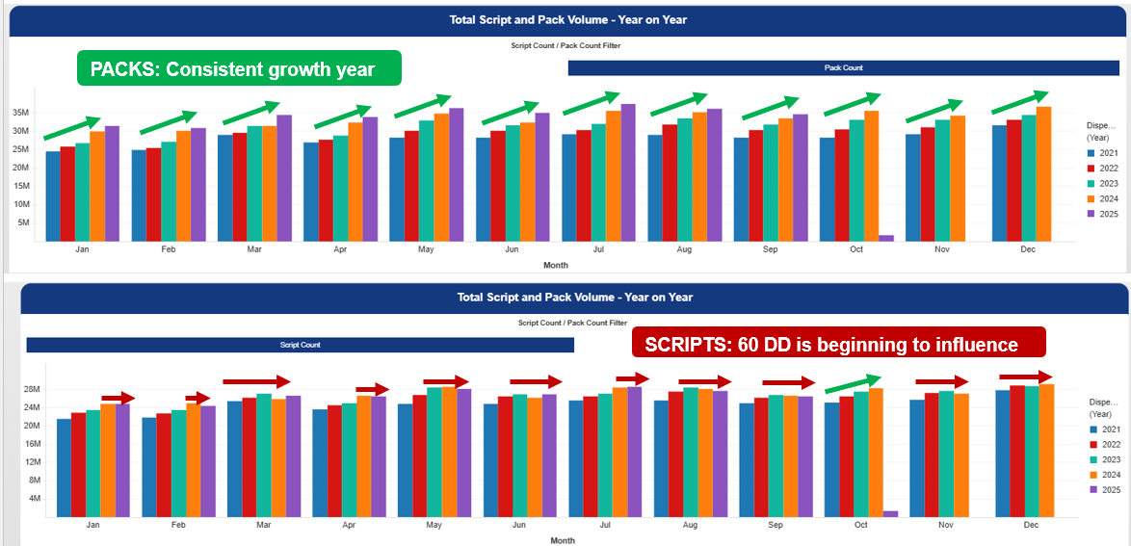
Figure 1. The top chart shows packs volume from 2021 to 2025, whilst the bottom chart shows script volume. This highlights the flattening of script volumes that 60DD has driven.
Equally, declining visitation amplifies the value of every interaction. Each customer who walks through the door represents an opportunity for meaningful health discussions and companion product recommendations that strengthen both outcomes and loyalty. With significant efficiency gains now supporting administrative tasks, pharmacists are expected to spend less time out the back and more time out the front — engaging, advising and adding clinical and commercial value to every encounter.
The question for 2026 is not whether pharmacy will change — it’s how each operator will adapt. How are you driving more people through the door beyond the script? Are you capturing demand created by the expanding scope of practice? And can independent pharmacies keep pace when compliance constraints make above-the-line service promotion harder to execute at scale?
For community independents, the challenge — and opportunity — lies in hyper-local connection: leveraging reputation, relationships, and data-driven insights to attract visitation beyond traditional needs-based scripts. For banners and corporatised networks, scale and compliance discipline provide the advantage — enabling brand consistency, centralised marketing, and the ability to execute across hundreds of sites with precision – something suppliers readily lean into.
In this new equilibrium, the winners will be those who turn data into direction, compliance into capability, and scope into sustained footfall. Pharmacy’s future won’t be measured by scripts alone — but by the intelligence, agility, and connection behind every one of them.

Prescription Market
Prescription market sales have again seen double digit growth in terms of value for October 2024 to September 2025 when comparing with the previous 12 months (Figure 2). Noting this is from a sales perspective and in contrast to script numbers which are actually flat (Figure 1).
+10.8%
Prescription Sales
Oct 2023 – Sept 2024 $18.4 billion
Oct 2024 – Sept 2025 $20.4 billion
Figure 2. Prescription sales comparison over the two reporting periods
Sales growth has concentrated in select high-value segments, with biologics, immunomodulators, and advanced metabolic agents accounting for a disproportionate share of value gains. Traditional chronic categories — cardiovascular, nervous system, and alimentary — remain the volume backbone.
This divergence underscores not just a maturing but a redefining moment for pharmacy, where the profession’s full scope of practice is becoming essential to community health. As GP availability remains stretched and recent government efforts to stimulate bulk billing show limited traction, pharmacists have stepped up to fill critical access gaps — providing prescribing, vaccination, and medication management services that support patients with increasingly complex and chronic needs. For years, pharmacists have been ready to take on this expanded role; now, with political recognition finally catching up, the sector stands poised to deliver more personalised, locally accessible care than ever before — ensuring that no patient falls through the cracks of an overstretched primary care system.
Figure 3: The top ten prescription categories remain either growing or stable, with only a few notable exceptions. Anti-infectives have softened following the decline in COVID-related treatment volumes, while Blood and Blood-Forming Organs contracted due to generic competition for Xarelto and Eliquis price reductions.
Antineoplastics & Immunomodulators
Pharmacy Value: $4.11B | Value Growth: +12.9%
High-cost specialty medicines continue to define this segment, even as script volumes decline. Growth was driven by biologics such as dupilumab (Dupixent) and upadacitinib (Rinvoq), with steady contributions from ustekinumab (Stelara) and darolutamide (Nubeqa). Meanwhile, legacy immunotherapies like adalimumab (Humira & biosimilars) faced contraction due to biosimilar entry. Market leadership remains with Janssen-Cilag, Sanofi-Aventis, and AbbVie, whose portfolios anchor much of pharmacy’s oncology and immunology value. The top therapies in this segment span autoimmune, inflammatory, and oncologic diseases—from eczema, asthma, and ulcerative colitis to rheumatoid arthritis and prostate cancer—highlighting pharmacy’s increasing involvement in the continuum of complex, chronic care. Pharmacists now play an essential role in managing adherence, patient counselling, and cold-chain logistics, while supporting transitions between biologics and biosimilars to maintain therapeutic continuity and confidence in specialty medicine use.
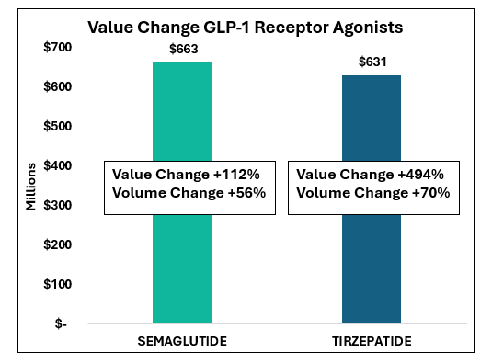
Alimentary Tract & Metabolism
Pharmacy Value: $3.99B | Value Growth: +45.7%
The standout performer of the year, this category continues to surge on the strength of advanced diabetes and metabolic agents. GLP-1 receptor agonists semaglutide and tirzepatide have redefined therapy management, together accounting for a substantial portion of total growth. Their rise underscores the shift from traditional oral therapies toward injectables and weight-management formulations. Novo Nordisk and Eli Lilly dominate the corporate landscape, driving innovation and patient demand. Pharmacists are increasingly central in supporting initiation, education, and adherence for these complex regimens, ensuring safety, cold-chain integrity, and continuity of care.
Nervous System
Pharmacy Value: $3.47B | Value Growth: +6.5%
The nervous system category continues to expand, propelled by ADHD, migraine, and chronic pain therapies. Lisdexamfetamine and methylphenidate remain dominant as ADHD diagnosis rates continue to rise, while biologics such as fremanezumab (Ajovy) for migraine and ofatumumab (Kesimpta) for multiple sclerosis drive the specialty end. Key manufacturers Takeda, Novartis, and Sandoz lead share. Pharmacists are vital in managing complex polypharmacy, mental-health support, and adherence for chronic neurological conditions requiring sustained, personalised intervention.
Figure 4: GLP-1 receptor agonists for weight loss and diabetes continue to be key growth drivers for the Alimentary & Metabolism category
Cardiovascular System
Pharmacy Value: $2.52B | Value Growth: +12.6%
Cardiovascular remains a foundation of pharmacy care, showing renewed growth on the back of lipid-lowering and heart-failure innovations. While legacy statins such as rosuvastatin and atorvastatin continue to dominate by volume, premium therapies like sacubitril + valsartan (Entresto) and inclisiran (Leqvio) are reshaping value mix. Apotex and Arrow under the DBG portfolio along with, Alphapharm (Viatris) and Novartis maintain strong corporate presence. With ageing demographics and rising multimorbidity, pharmacists’ roles in point of care screening, adherence support, and medication reviews are increasingly pivotal to improving cardiovascular outcomes.
Respiratory System
Pharmacy Value: $1.45B | Value Growth: +8.0%
Respiratory therapies saw steady growth, underpinned by innovation in biologics and triple-combination inhalers. Elexacaftor + ivacaftor + tezacaftor (Trikafta) transformed cystic-fibrosis management, while budesonide + formoterol and fluticasone + salmeterol sustained the chronic airways base. GSK, Vertex, and AstraZeneca dominate corporate share. Pharmacist programs such as those led by AXE health services have helped measure and increase adherence to therapy and these types of programs remain key to device technique training, step-up/step-down asthma support, and biologic handling—ensuring therapy optimisation and adherence.
Systemic Anti-Infectives
Pharmacy Value: $1.37B | Value Growth: −20.9%
A sharp contraction followed the wind-down of COVID-related antivirals such as molnupiravir and nirmatrelvir + ritonavir as more individuals appear to ride out rather than treat their COVID infections. Traditional antibiotics—amoxicillin and cefalexin—remain staples but have normalised to pre-pandemic levels. MSD, Pfizer, and Gilead retain leading positions. The category’s decline highlights a return to routine infection patterns, with pharmacists refocusing on antimicrobial stewardship, vaccination, and public-health education to mitigate resistance.
Genito-Urinary System & Sex Hormones
Pharmacy Value: $951M | Value Growth: +1.0%
This category remained stable, supported by ongoing use of hormonal therapies and urological agents. Tadalafil volumes grew strongly, reflecting rising demand for men’s health and erectile dysfunction management, though overall category value was tempered by falling unit prices and generic competition. Bayer, Besins, and Aspen Pharma continue to hold leading corporate share, while Wesfarmers’ Priceline Pharmacy has been pivotal in developing the menopause segment from a pharmacist-led perspective—anchoring this within its broader female-friendly health proposition. Meanwhile, hub-and-spoke telehealth providers such as MOSH and Pilot have driven the men’s health and ED space, extending access and normalising treatment pathways that increasingly intersect with pharmacy for dispensing and follow-up care.
Blood & Blood Forming Organs
Pharmacy Value: $917M | Value Growth: −5.6%
After several years of steady gains, the anticoagulant and iron-replacement segments softened. Apixaban and rivaroxaban remain core contributors but have plateaued amid generic substitution and price disclosure pressures. Offsetting some decline were stabilising trends in clopidogrel and parenteral iron products. Market leadership rests with Bayer, Bristol-Myers Squibb, and Seqirus, with community pharmacy remaining essential for medication counselling, monitoring interactions, and supporting adherence for patients on long-term antithrombotic therapy.
Sensory Organs
Pharmacy Value: $873M | Value Growth: +5.1%
This category remains solid, anchored by ophthalmic treatments such as aflibercept and ranibizumab, which are used to treat age-related macular degeneration (AMD)—a leading cause of blindness in older Australians—as well as diabetic eye disease and retinal vein occlusion, where fluid leaks and damages the retina. Growth has been supported by newer anti-VEGF (vascular endothelial growth factor) therapies such as faricimab, which offers longer dosing intervals and improved convenience for patients. Roche, Bayer, and Novartis continue to lead this market, supported by expanding access to intravitreal injection therapies through ophthalmologist partnerships. For community pharmacy, the focus is on maintaining cold-chain integrity, managing timely supply for specialist clinics, and supporting patient education around eye-health maintenance—particularly for ageing populations and those managing diabetes-related vision risks.
Musculo-Skeletal System
Pharmacy Value: $784M | Value Growth: +5.2%
Growth in this segment has been anchored by osteoporosis and chronic pain management. Denosumab and celecoxib continue to underpin value, complemented by selective biologics such as tocilizumab and abatacept for autoimmune joint disease. Amgen, Roche, and Bristol-Myers Squibb maintain strong positions. As ageing populations drive demand, pharmacists play a central role in bone-health education, Dexa scan referrals, analgesic stewardship, and ensuring safe biologic use for long-term musculoskeletal care.

Consumer Health – front of shop
The OTC market generated $9.6 billion in pharmacy sales, reflecting a 2.7% decline year-on-year as several pandemic-inflated categories reverted toward normal trading levels. While respiratory and vitamin markets contracted slightly from last year’s peaks, they continue to anchor pharmacy foot traffic and consumer loyalty. The landscape is characterised by resilience in everyday health segments such as pain relief, digestive care, and dermatology, alongside sustained interest in preventative health and evidence-led self-care. Growth areas like eye care, digestive wellness, and medical-grade skincare illustrate consumer readiness to spend where efficacy is clear. Competitive intensity from online and grocery channels remains a headwind, but pharmacy retains an edge in trust, professional recommendation, and condition-led advice — critical differentiators as consumers increasingly blend therapeutic and lifestyle purchasing decisions.
-2.7%
OTC Sales
Oct 2023 – Sept 2024 $9.6 billion
Oct 2024 – Sept 2025 $9.3 billion
Figure 5. OTC sales comparison over the two reporting periods
Figure 6. The top 15 OTC categories and their value change over the 2 reporting periods.

Cough Cold and Other Respiratory Products
Pharmacy Value: $1.09B | Value Growth: −2.8%
Respiratory remains the largest OTC market, normalising from recent elevated peaks. Demand is anchored by cough, cold and decongestant lines with a steadier, more seasonal pattern returning. While value dipped modestly year-on-year, baseline need persists and the category continues to drive footfall. For pharmacy operators, this remains a high-velocity basket builder where service (triage, interaction checks, age-appropriate options) and compliance with scheduling rules protect both outcomes and trust.
Vitamins, Minerals and Nutritional Supplements
Pharmacy Value: $1.01B | Value Growth: −1.6%
VMS holds its scale despite a slight value decline, reflecting a more discerning consumer pivoting toward condition-led routines (immunity, sleep, bone health) and evidence-backed formulations. Mix continues to favour formats and actives perceived as high quality, though promotional intensity and online competition weigh on growth. In-store guidance, regimen building, and attachment to chronic-condition conversations help sustain loyalty and maintain share against digital channels.
Pain Relief
Pharmacy Value: $860M | Value Growth: +1.0%
Pain remains a resilient pillar, with steady everyday use across paracetamol, ibuprofen and combination SKUs. Value lift is modest, aided by pack architecture and targeted propositions (migraine, back pain). Safety guidance (dose limits, interactions, age/pregnancy considerations) and stewardship conversations (e.g., non-pharmacological options, referral flags) continue to differentiate the pharmacy channel while supporting appropriate self-care.
Digestive and Other Intestinal Products
Pharmacy Value: $628M | Value Growth: +3.1%
Digestive health trends remain favourable as consumers manage reflux, diarrhoea/constipation and gut comfort more proactively. Growth points to broad participation across fast-relief and longer-term management (e.g., fibre, enzymes, microbiome-supporting products). Pharmacy advice that links symptoms to product selection, lifestyle triggers and medicine reviews (e.g., reflux with polypharmacy) supports better outcomes and repeat engagement.
Beauty Products for Women
Pharmacy Value: $604M | Value Growth: −6.0%
Women’s beauty softened, cycling strong prior gains and facing heightened competition from online and specialty beauty retailers. Consumers continue to trade up selectively into dermatology-inspired routines, though promotional elasticity is high. Pharmacy advantage lies in credibility and curation — connecting skin needs to regimen design, sun protection and sensitive-skin care, while using sampling and consultation to protect conversion.
Skin Treatment
Pharmacy Value: $490M | Value Growth: +3.7%
Medicalised skincare (eczema, dermatitis, antifungal, wound/repair) shows healthy momentum. Gains reflect ongoing demand for sensitive-skin and steroid-sparing options alongside proven emollient and barrier strategies. Pharmacist-led assessment (severity, red flags, step-up/step-down, trigger control) and clear regimen instructions drive adherence, brand loyalty and reduce treatment failure — reinforcing pharmacy’s clinical retail role.
Fragrances
Pharmacy Value: $467M | Value Growth: −20.2%
Fragrances retreated sharply after a strong period of gifting-driven demand and promotional spikes. The category remains important for seasonal trade and margin but is highly price-comparable online. Pharmacy can preserve value via eventing, exclusives, and tie-ins with beauty/skincare to lift basket size — while keeping inventory and promotional planning tightly aligned to peak moments.
Hair Products
Pharmacy Value: $399M | Value Growth: +0.5%
Haircare held steady, supported by medicated/scalp-health segments (anti-dandruff, sensitivity) and treatment-led routines (damage repair, hydration). Premiumisation is present but moderated by value-seeking behaviour. Positioning pharmacy as a “scalp clinic” — linking symptom enquiry to targeted regimens and counselling on frequency/technique — sustains differentiation from grocery and pure-play online.
Unisex Beauty Products
Pharmacy Value: $388M | Value Growth: +1.9%
Unisex beauty continues to broaden, with functional skincare (SPF, hydration, barrier support) outpacing purely cosmetic plays. Growth reflects inclusive positioning and routine simplification. Pharmacy’s strength is in needs-based navigation and credible recommendations that connect skin type, sensitivity and environment (e.g., work, sport, screen time) to simple, sustainable routines.
Eye Care
Pharmacy Value: $281M | Value Growth: +5.2%
Eye care grows solidly on rising dry-eye and allergy prevalence, driven by screen exposure, ageing and environmental factors. Demand favours preservative-free and targeted formulations, with technique and regimen clarity essential to success. Pharmacists remain first-line for product selection, lens care advice and referral triggers — linking OTC relief with long-term ocular health.

Conclusion
Pharmacy closes 2025 transformed yet resolute — navigating policy shifts, rising specialty spend, and a marketplace increasingly defined by purpose over prescription volume. Specialty medicines are reshaping the dispensary, demanding deeper clinical understanding and patient support, while the front of shop evolves in parallel — from general wellness to condition-specific OTC solutions tailored to individual need. Together, these trends mark a convergence of clinical insight and consumer relevance.
Large banners will continue to leverage above-the-line reach and consistency of offer, but community operators that execute locally, personalise engagement, and connect meaningfully with patients will remain the industry’s heartbeat. Across all models, the real differentiator is delivery — not of scripts, but of personalised care. In a climate where trust, service, and experience define loyalty, execution and connection have never mattered more. The future of pharmacy lies in mastering both the science and the sentiment of community care.

